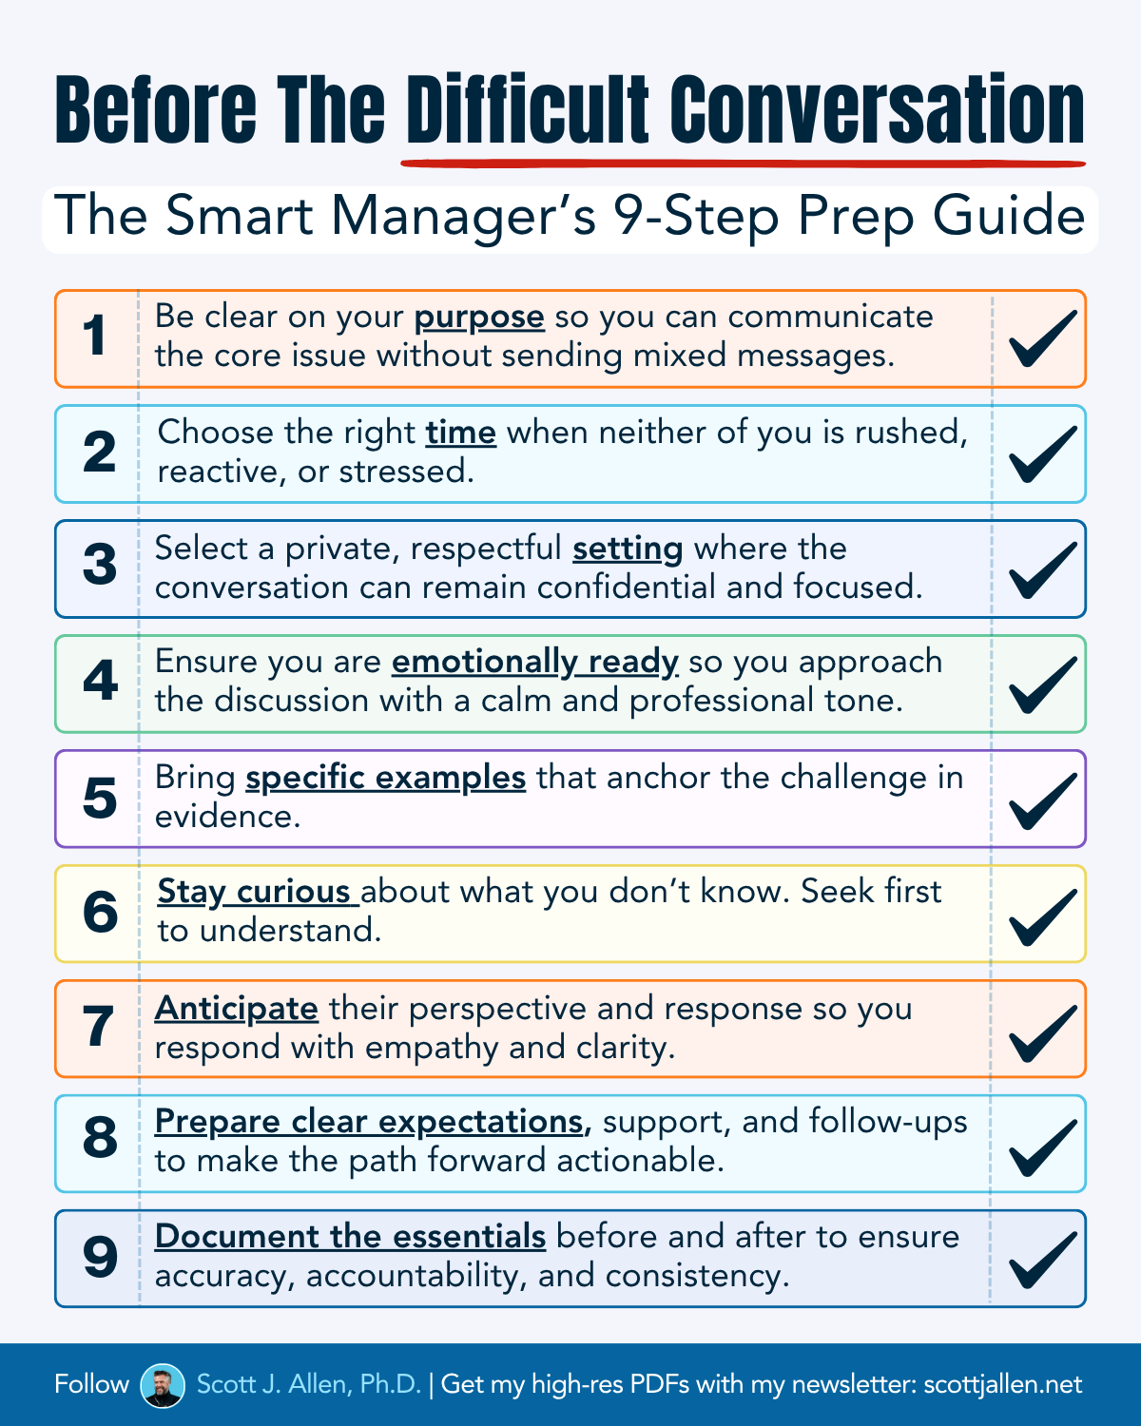

Feedback
- Feedback is information given to someone about their past behavior or performance. It highlights what worked, what did not, and what could be improved. The purpose is to raise awareness and reinforce or redirect behavior.

Communicate the behavior (Step 1): A goal of this step is to communicate the individual's behavior in a way that does not make the other feel defensive or disconfirmed. This means that you will have to regulate your emotions (ride the elephant), which can be challenging, especially when you are feeling frustrated, angry, sad, or disappointed with the other person. You must name the specific, measurable, observable behavior/outcome (SMOB) (e.g., poor follow-through, negativity).
Own your statement (Step 2): Be sure to communicate in a way that involves only you and the other individual. The discussion can get messy if you bring others who are not present into the conversation (e.g., friends or co-workers). If possible, keep the dialogue focused on the two of you and your specific observations of the other person’s behavior. Avoid accusatory statements that could inflame the situation. Stick with “I” statements (e.g., “I’ve observed,” “I feel that…”).
Name the impact (Step 3): The other person should be led to understand how their behavior has impacted you (e.g., lost time, hurt feelings, mistrust, a missed opportunity, increased stress) and the negative consequences. Again, if possible, you will want to keep this between you. Involving others not in the room can confuse, muddy, and divert the conversation. Note: the first three steps do not need to take long. A common pitfall is that the person confronting says too much in these first three steps. Example: “When XYZ happens, this is the impact.”
- “When you hold some people accountable and let others slide, it creates mistrust, breeds dysfunction, and causes tension” or “As a partner, when you do not follow the expectations and engage as you are supposed to, it sets a tone that it’s acceptable and ok.”

Fully listen (Step 4): After you move past the first three steps, ask for input or agreement and fully listen to the other person. This is where your improvisational skills come into play. The other person may admit fault, lash out, and deny all charges. It's vital that you pause and actively listen to understand their mindset. While you do not have to agree, it's critical that you do not interrupt and provide the other person the space to respond. In this step, it is also essential to maintain eye contact and control the pace (the conversation can speed up when emotions are involved).
- The cast of characters: Realistic Rita, Silent Steve, Ina the Informant, Impatient Irina, Negative Neal, Roger the Rabbit Hole, Blissfully Ignorant Bill, “Making It Bigger Matt”, Emotional Edgar, Slippery Sal, Angry Alan, “But What About” Bob, Teflon Ted, Lying Larry, Gaslighting Gary, Privileged Partner Pete

Reflect and respond (Step 5): Based on how the other person responds (realistically, unrealistically), it is essential to remember to regulate your emotion and move forward to the next step (if there is agreement) or go back to the first step if the other person disagrees with your perspective. If the other person responds in a way you were not expecting, it is realistic to pause and ask for some time to gather your thoughts. Likewise, at some point, you may need to “agree to disagree” and focus on moving forward.
Coaching
- Coaching is a developmental conversation focused on helping someone grow, improve, and reach future goals. It uses questions, guidance, and support to build skills, expand thinking, and increase ownership.

Options moving forward (Step 6): Assuming normal circumstances, this step involves a simple question – “How can we ensure that we are not in this situation moving forward?” Even if you and the other person cannot agree on the facts, the two of you must understand and decide on some options for a better future. Thus, this step concerns the two of you searching for a win/win, if possible. Note: this step may take some time. However, it's critical that you brainstorm 4-5 options to move forward.
Negotiate solution/Gain agreement (Step 7): Through the dialogue, agree upon 2-3 options and, if possible, ensure that they are win-win toward a mutually agreed-upon outcome. If appropriate, frame using specific, measurable, achievable, relevant, and time-bound goals (SMART). The specifics will help you gauge progress and set the stage for the follow-up conversations. Once you think you have clarity, you can do a talk-back (the listener repeats back what they heard to the speaker to confirm mutual understanding). You will also want to follow up with an email to ensure both parties understand the path forward.
Thank you (Step 8): Thank the other individual for their time and communicate your desire for a better future. After all, this conversation could start a better future for both parties. You have expressed to the other individual that you care about their well–being.

Case Studies
Directions:
- Take five minutes and quickly review each case
- Each of you chooses one that resonates (you should each choose a different case)
- Over the three rounds, each one of you plays the role of initiator/responder/observer
  - Initiator of the conversation – follow the model and engage
  - Responder – play one (or a few) of the characters
  - Observer – Take notes and share observations for the initiator (how did they do?)
- Take 10 minutes for each case (5 minutes to role play and 5 minutes of debrief)
- Please call me over with questions!

Manager Consistently Missing Client Deadlines
Background: A senior manager has repeatedly missed important filing deadlines for several key clients despite having sufficient staff and resources.
Challenge: These lapses threaten client relationships and the firm’s reputation for reliability. The Partner must address the issue directly while maintaining the manager’s confidence and fostering a culture of respect.
Ultimate Goal: Have an honest conversation to clarify expectations, find root causes, and develop a clear plan to avoid future issues. Reinforce the company’s commitment to quality and timeliness while supporting the manager's success.

High-Performing Senior Associate Resisting Business Development
Background: A senior associate produces excellent technical work but consistently avoids engaging in business development activities, such as networking events, prospect meetings, and cross-selling opportunities.
Challenge: Without early client engagement, the firm’s pipeline and succession planning are at risk. The Partner must confront this resistance while avoiding alienating a key technical contributor.
Ultimate Goal: Help the associate see business development as a key part of career growth. Work together to find small, manageable steps to build confidence and skills in client-facing activities.

